Mixed Zigzag Shapes
# Source: AI Source: Provided by: [Data Path: Persons Table -> ID Column: 1, Name_En Column: Motasem Essam] -> From: [ChatGPT] on [7/25/2026]
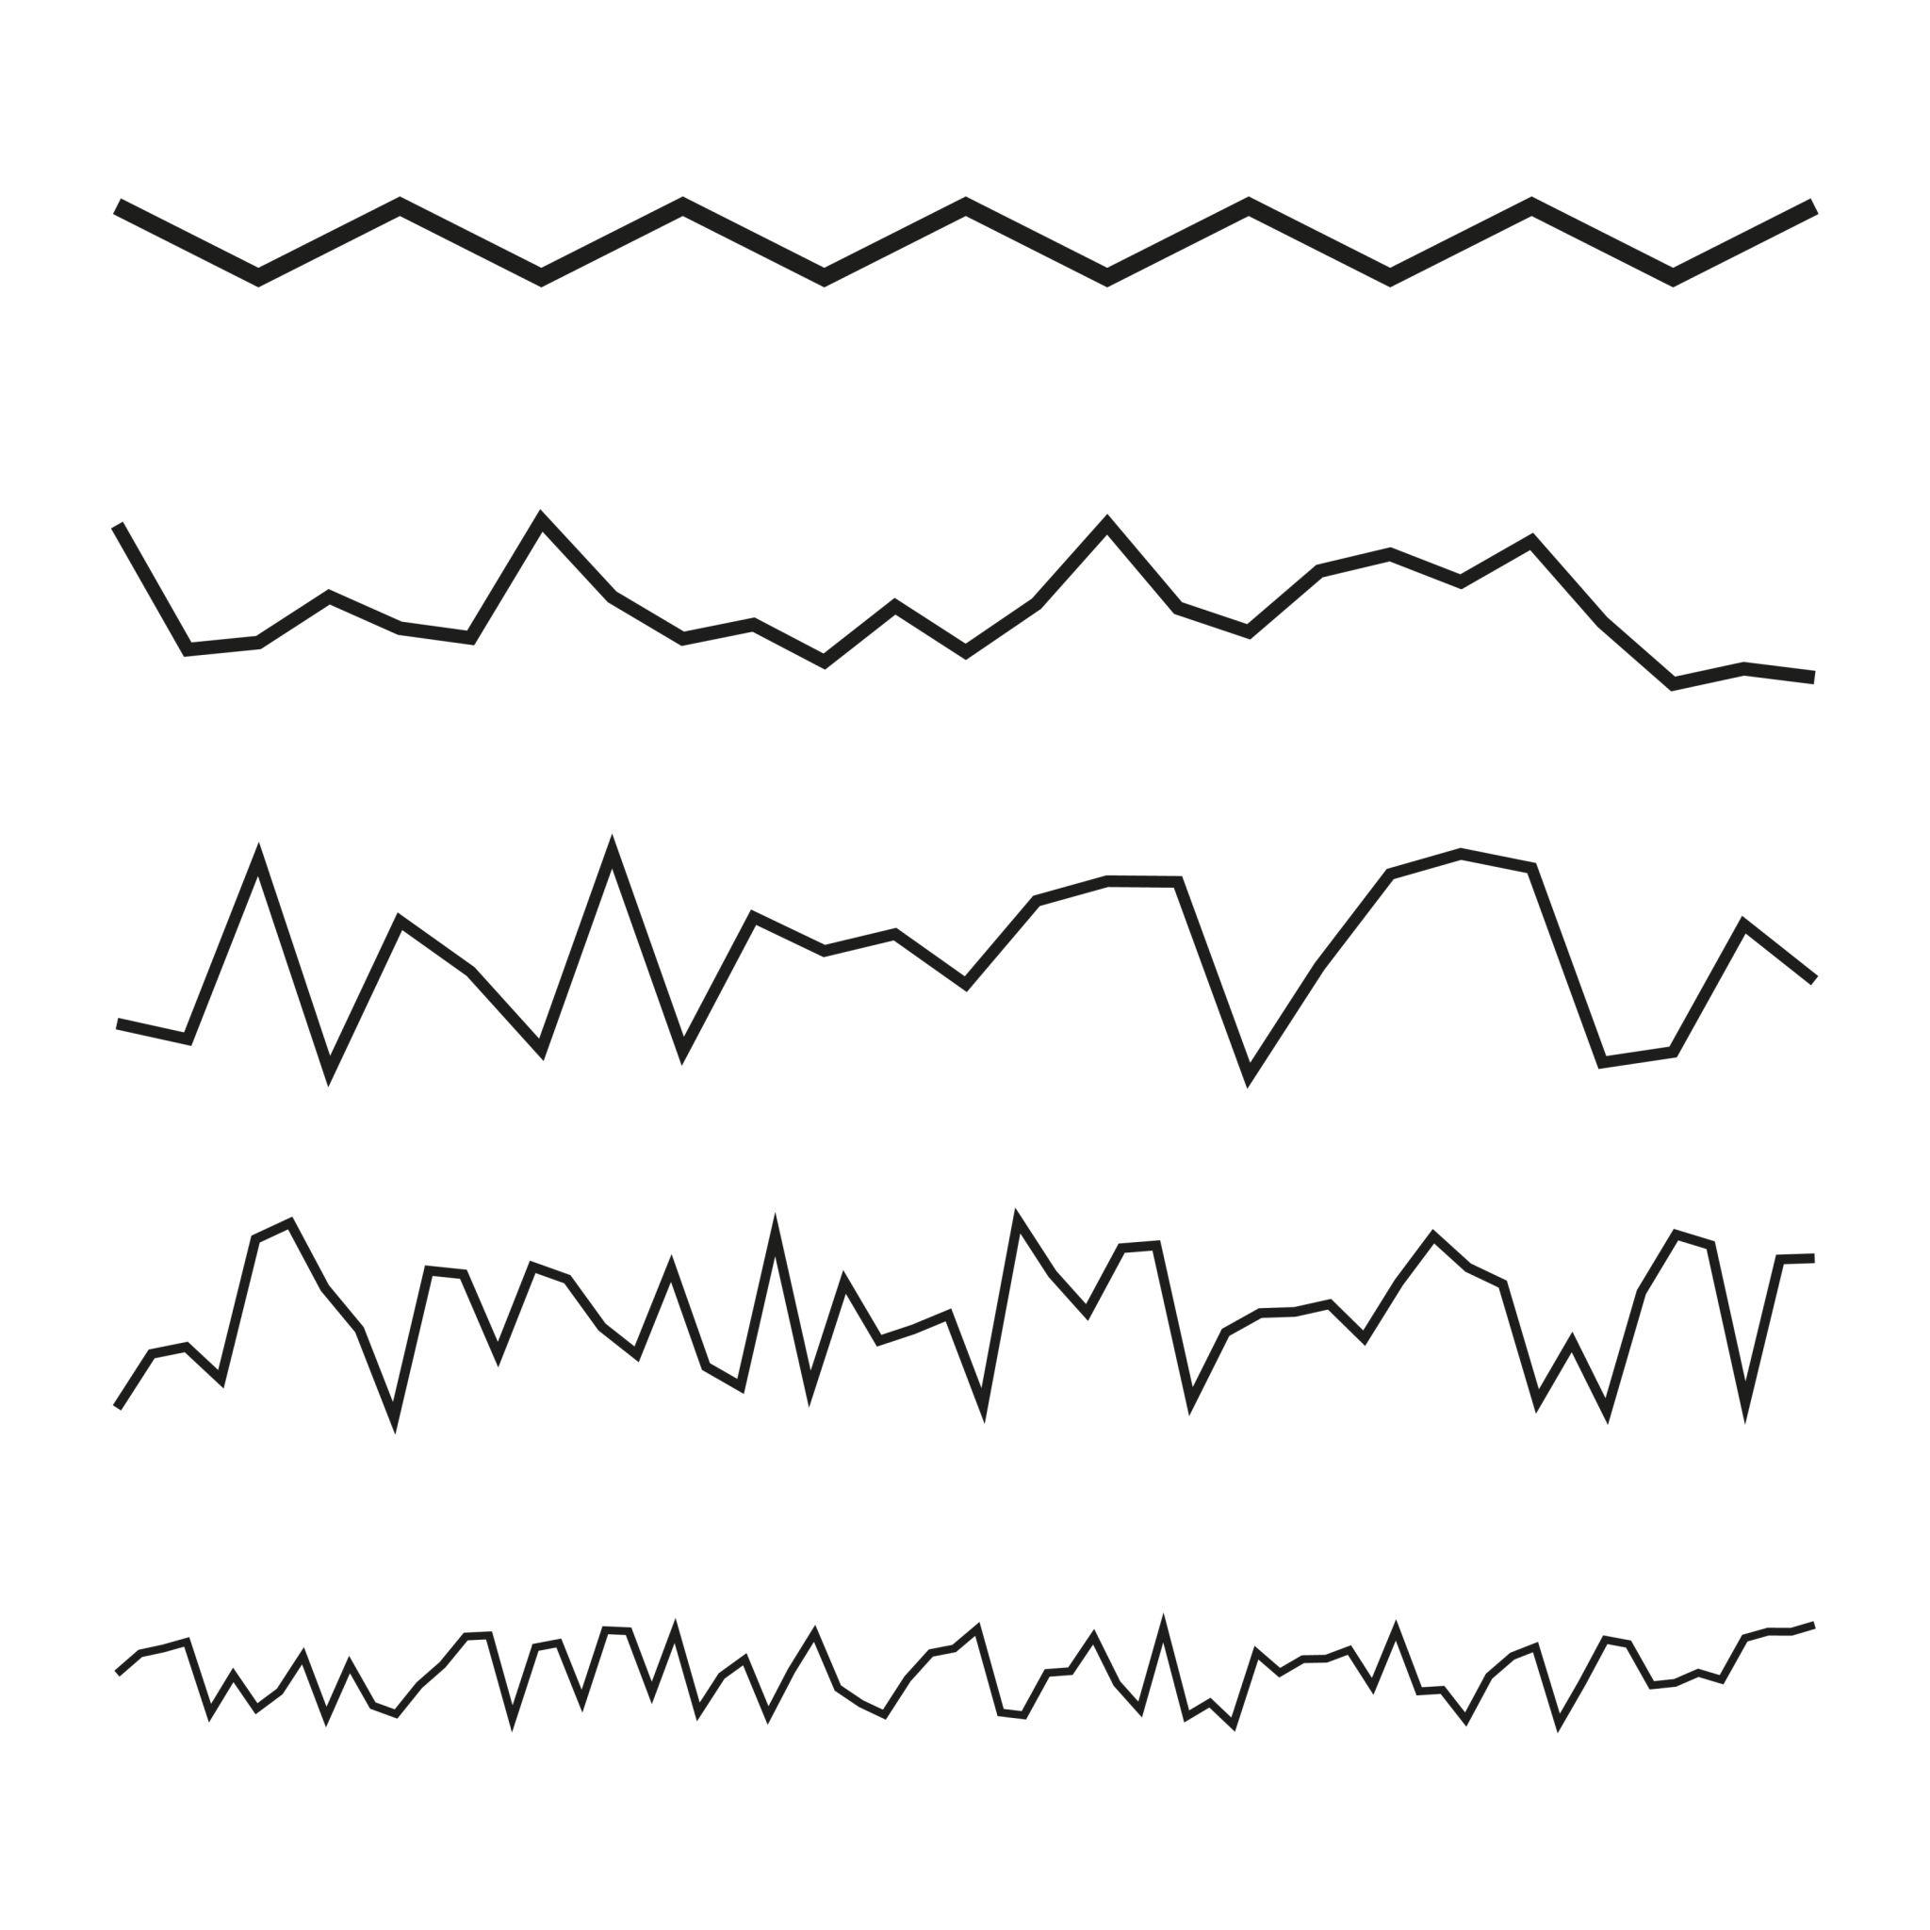
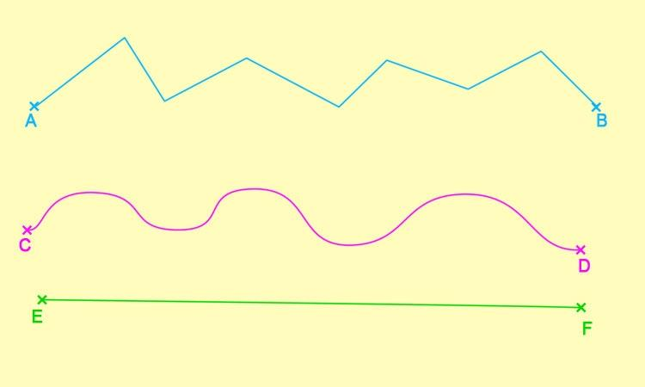
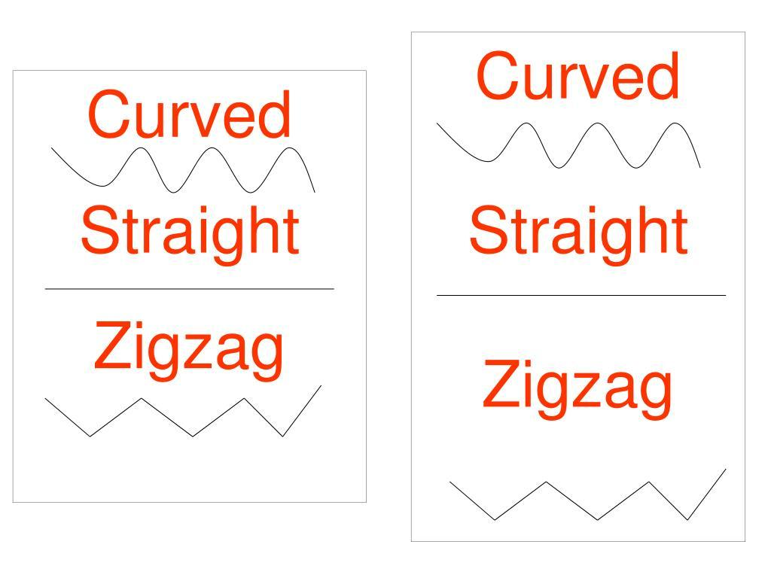

Definition
# Source: AI Source: Provided by: [Data Path: Persons Table -> ID Column: 1, Name_En Column: Motasem Essam] -> From: [ChatGPT] on [7/25/2026]
A Mixed Zigzag Shape is a zigzag shape that combines different geometric characteristics or zigzag patterns within the same shape.
For example, a mixed zigzag may combine:
- regular and irregular sections,
- different segment lengths,
- different turning angles,
- symmetric and asymmetric portions,
- or different types of zigzag patterns.
The term mixed zigzag shape is descriptive rather than a strict standardized mathematical classification.

Fundamental Concept
# Source: AI Source: Provided by: [Data Path: Persons Table -> ID Column: 1, Name_En Column: Motasem Essam] -> From: [ChatGPT] on [7/25/2026]
A mixed zigzag is formed when different zigzag characteristics occur within the same overall shape.
For example:
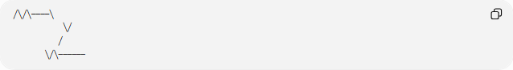
╱╲╱╲────╲
╲╱
╱
╲╱╲──────
One section may have a regular repeating pattern, while another section may have different segment lengths or angles.

Main Characteristics
# Source: AI Source: Provided by: [Data Path: Persons Table -> ID Column: 1, Name_En Column: Motasem Essam] -> From: [ChatGPT] on [7/25/2026]
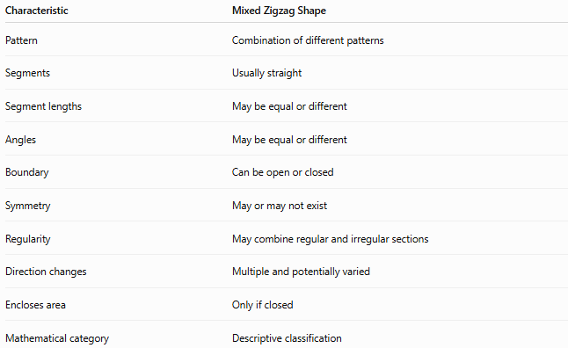
Characteristic | Mixed Zigzag Shape
Pattern | Combination of different patterns
Segments | Usually straight
Segment lengths | May be equal or different
Angles | May be equal or different
Boundary | Can be open or closed
Symmetry | May or may not exist
Regularity | May combine regular and irregular sections
Direction changes | Multiple and potentially varied
Encloses area | Only if closed
Mathematical category | Descriptive classification

Types of Mixed Zigzag Shapes
# Source: AI Source: Provided by: [Data Path: Persons Table -> ID Column: 1, Name_En Column: Motasem Essam] -> From: [ChatGPT] on [7/25/2026]
A useful classification is:
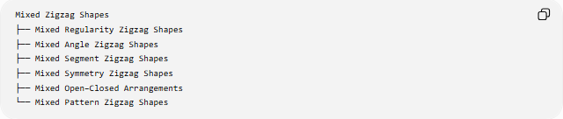
Mixed Zigzag Shapes
├── Mixed Regularity Zigzag Shapes
├── Mixed Angle Zigzag Shapes
├── Mixed Segment Zigzag Shapes
├── Mixed Symmetry Zigzag Shapes
├── Mixed Open–Closed Arrangements
└── Mixed Pattern Zigzag Shapes

1-Mixed Regularity Zigzag Shapes
# Source: AI Source: Provided by: [Data Path: Persons Table -> ID Column: 1, Name_En Column: Motasem Essam] -> From: [ChatGPT] on [7/25/2026]
A Mixed Regularity Zigzag Shape contains both regular and irregular sections.
╱╲╱╲╱╲────╲╱──╲
The first section may repeat regularly, while the later section changes its pattern.

2-Mixed Angle Zigzag Shapes
# Source: AI Source: Provided by: [Data Path: Persons Table -> ID Column: 1, Name_En Column: Motasem Essam] -> From: [ChatGPT] on [7/25/2026]
A Mixed Angle Zigzag Shape contains different turning angles.
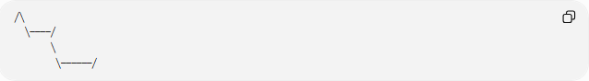
╱╲
╲────╱
╲
╲──────╱
The magnitude of the direction changes is not uniform throughout the shape.

3-Mixed Segment Zigzag Shapes
# Source: AI Source: Provided by: [Data Path: Persons Table -> ID Column: 1, Name_En Column: Motasem Essam] -> From: [ChatGPT] on [7/25/2026]
A Mixed Segment Zigzag Shape contains segments with different lengths.
╱╲──╱╲──────╱╲─╲
For example:
$$l_{1}=l_{2}≠l_{3}≠l_{4}$$
The exact relationship depends on the particular shape.

4-Mixed Symmetry Zigzag Shapes
# Source: AI Source: Provided by: [Data Path: Persons Table -> ID Column: 1, Name_En Column: Motasem Essam] -> From: [ChatGPT] on [7/25/2026]
Different portions of a zigzag may have different symmetry relationships.
For example, one portion may be arranged symmetrically while another portion breaks that symmetry.

5-Mixed Open–Closed Arrangements
# Source: AI Source: Provided by: [Data Path: Persons Table -> ID Column: 1, Name_En Column: Motasem Essam] -> From: [ChatGPT] on [7/25/2026]
An individual connected zigzag path is either open or closed. Therefore, an "open–closed" mixed arrangement normally refers to multiple zigzag components, where some components are open and others are closed.
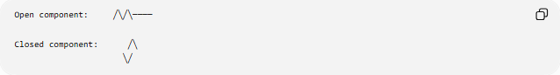
Open component: ╱╲╱╲────

Closed component: ╱╲
╲╱
This is more precisely described as a mixed collection of zigzag components rather than one single polygon.

6-Mixed Pattern Zigzag Shapes
# Source: AI Source: Provided by: [Data Path: Persons Table -> ID Column: 1, Name_En Column: Motasem Essam] -> From: [ChatGPT] on [7/25/2026]
A mixed pattern zigzag combines different zigzag arrangements, such as changes in:
- segment direction,
- segment length,
- turning angle,
- repetition,
- or local pattern.
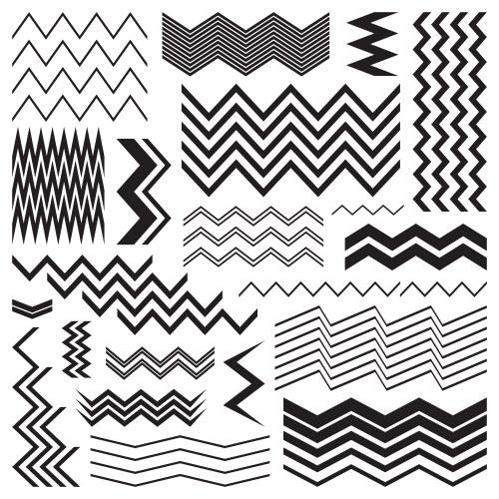
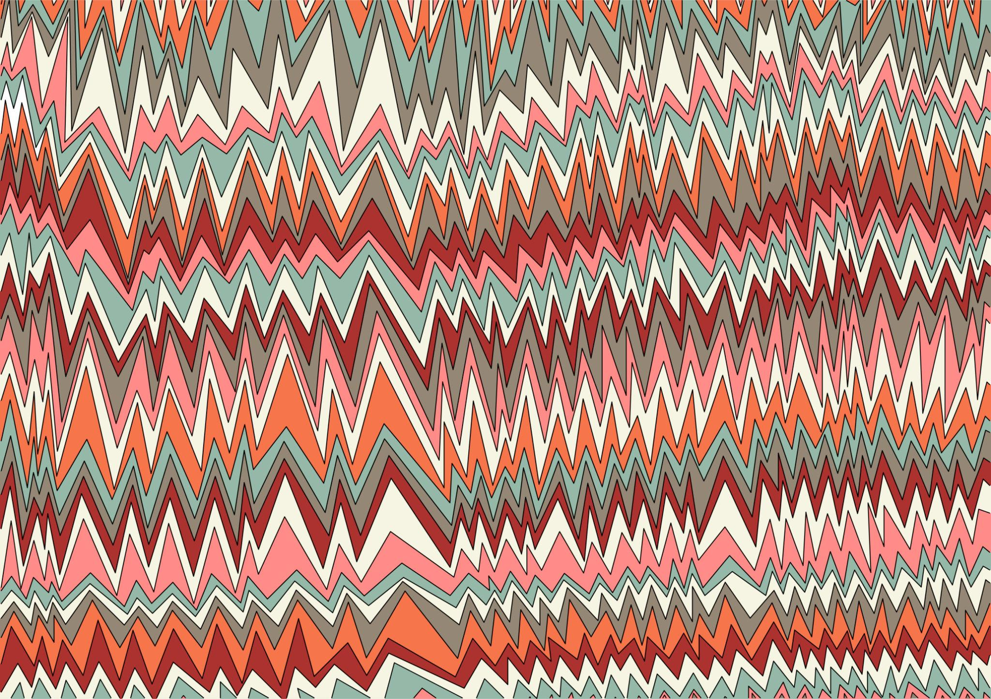
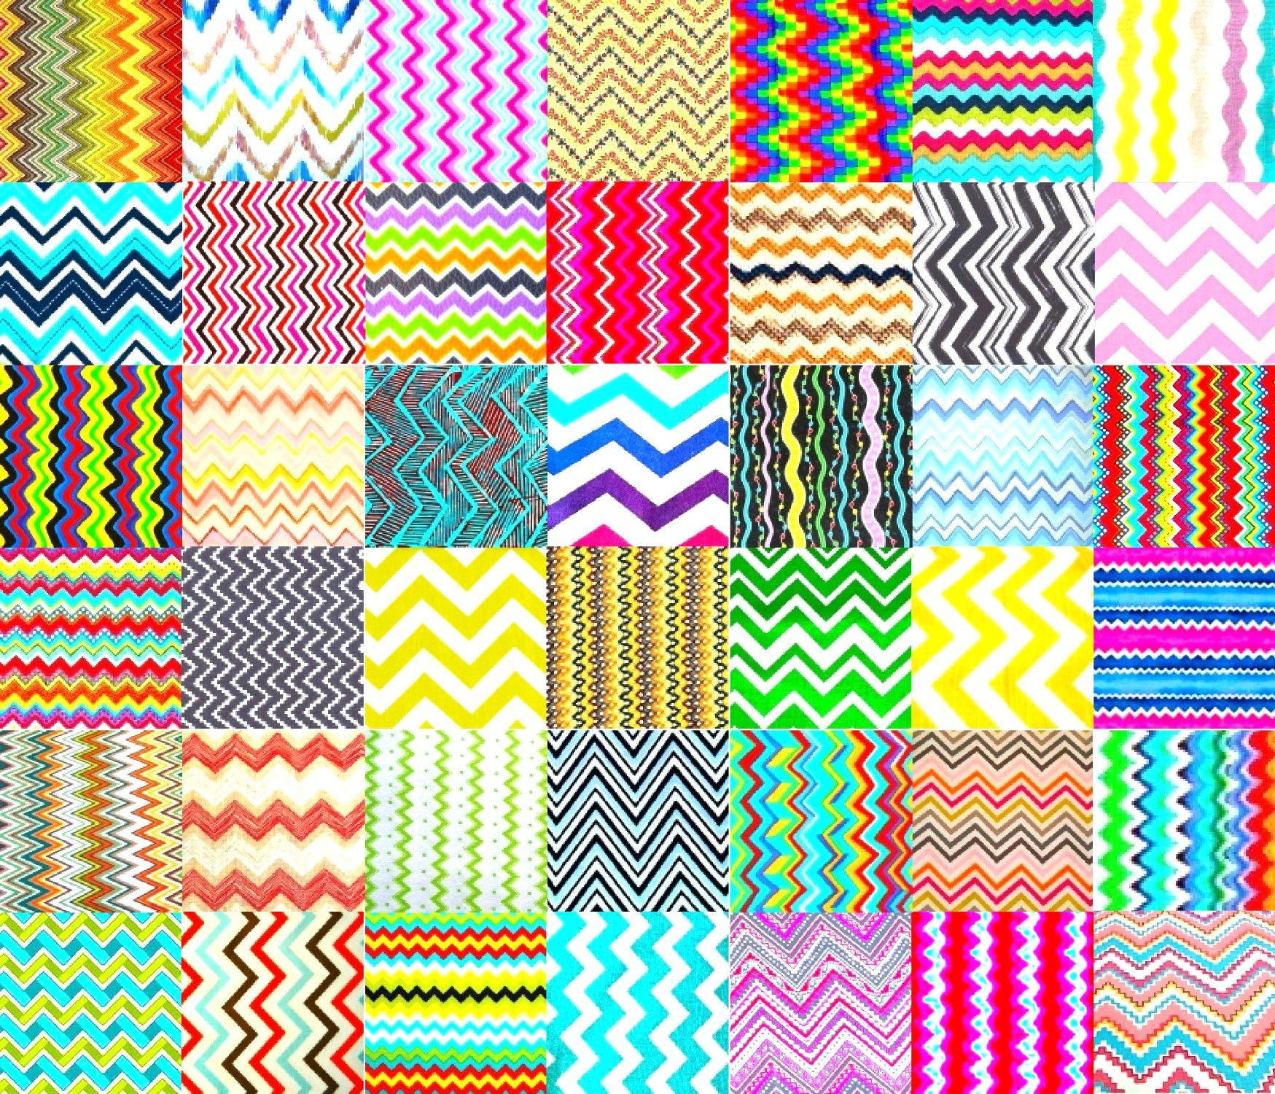
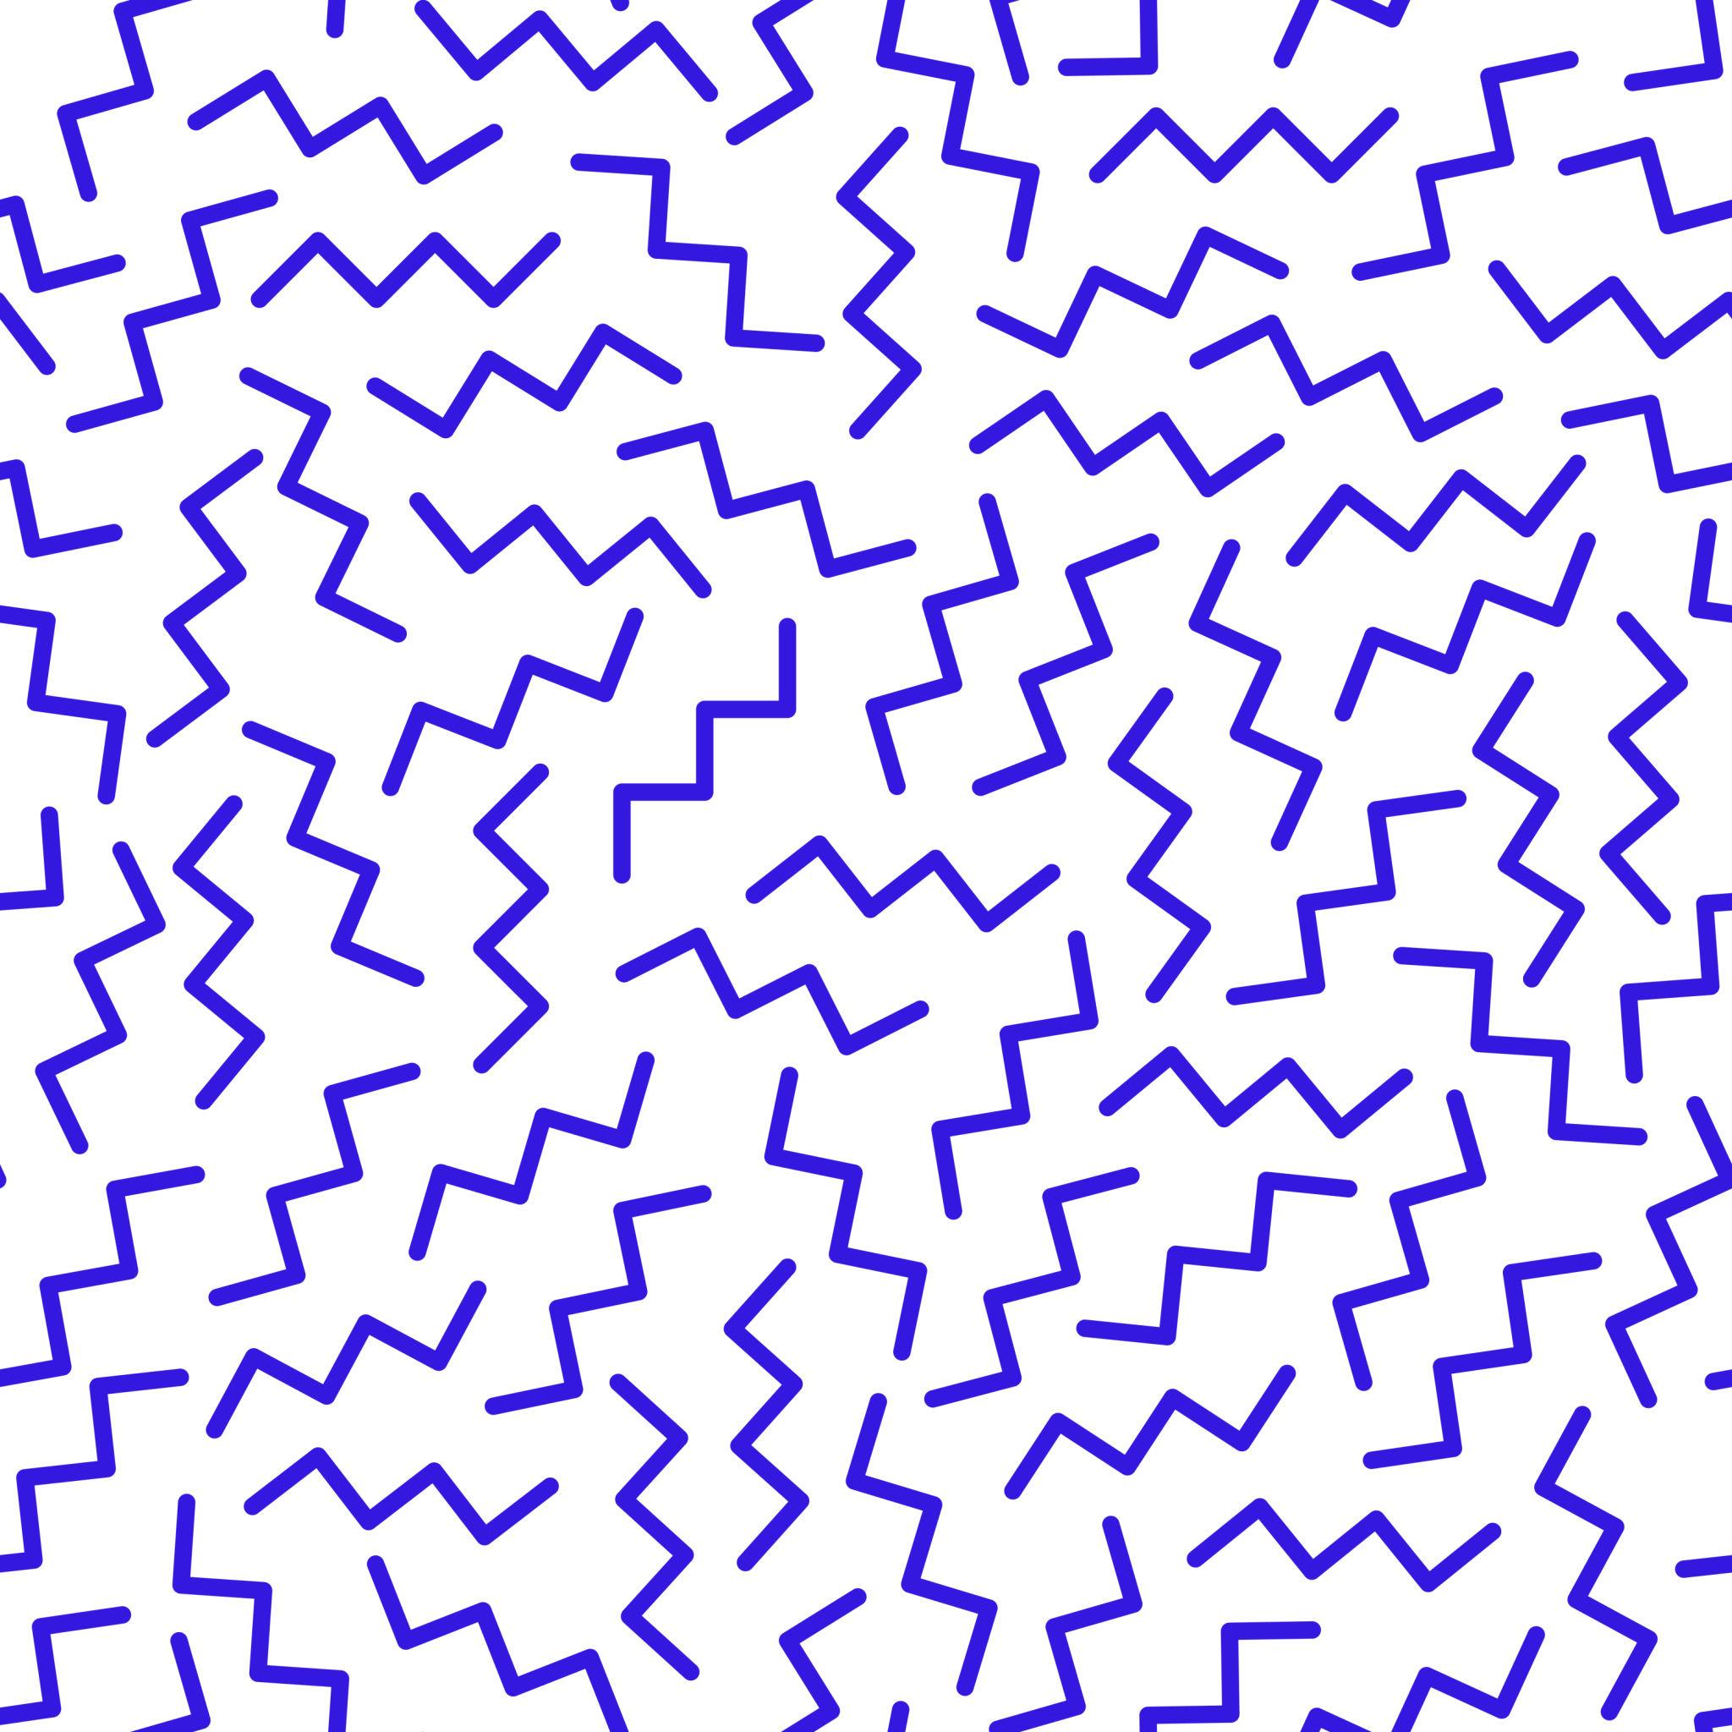

Open and Closed Mixed Zigzags
# Source: AI Source: Provided by: [Data Path: Persons Table -> ID Column: 1, Name_En Column: Motasem Essam] -> From: [ChatGPT] on [7/25/2026]
Mixed zigzag patterns can occur in both open and closed forms.
Open Mixed Zigzag
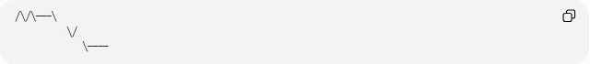
╱╲╱╲───╲
╲╱
╲────
The path has two endpoints.
Closed Mixed Zigzag
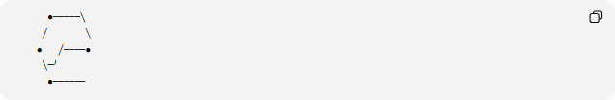
●─────╲
╱ ╲
● ╱────●
╲─╯
●──────
The boundary returns to its starting point and encloses a region.

Mathematical Properties
# Source: AI Source: Provided by: [Data Path: Persons Table -> ID Column: 1, Name_En Column: Motasem Essam] -> From: [ChatGPT] on [7/25/2026]
Total Length
For a mixed zigzag with segment lengths
$$l_{1},l_{2},…,l_{n}$$
the total length is:
$$\boxed{L=\sum_{i=1}^{n}{l_{i}}}$$
or:
$$\boxed{L=l_{1}+l_{2}+⋯+l_{n}}$$
Closed Mixed Zigzag
If the mixed zigzag forms a simple closed polygon with $n$sides, its interior-angle sum is:
$$\boxed{S=\left(n-2\right){180}^{∘}}$$
The fact that the pattern is mixed does not change this formula.
Area
If the closed mixed zigzag forms a polygon, its area can be found using appropriate polygon-area methods, such as:
- decomposition into simpler shapes,
- coordinate geometry,
- the shoelace formula.
For a self-intersecting boundary, however, the ordinary simple-polygon area interpretation may not apply directly.

Mixed vs. Regular Zigzag Shapes
# Source: AI Source: Provided by: [Data Path: Persons Table -> ID Column: 1, Name_En Column: Motasem Essam] -> From: [ChatGPT] on [7/25/2026]
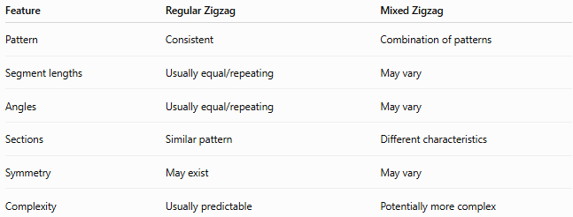
Feature | Regular Zigzag | Mixed Zigzag
Pattern | Consistent | Combination of patterns
Segment lengths | Usually equal/repeating | May vary
Angles | Usually equal/repeating | May vary
Sections | Similar pattern | Different characteristics
Symmetry | May exist | May vary
Complexity | Usually predictable | Potentially more complex

Mixed vs. Irregular Zigzag Shapes
# Source: AI Source: Provided by: [Data Path: Persons Table -> ID Column: 1, Name_En Column: Motasem Essam] -> From: [ChatGPT] on [7/25/2026]
These terms are related but not identical.
Irregular means that the zigzag does not follow a regular pattern.
Mixed means that different types or characteristics are combined.
Therefore, a mixed zigzag can contain irregular portions, but the term mixed emphasizes the combination of different characteristics.
$$\boxed{\text{Mixed}≠\text{Irregular}}$$

Examples

Example 1 – Regular + Irregular
# Source: AI Source: Provided by: [Data Path: Persons Table -> ID Column: 1, Name_En Column: Motasem Essam] -> From: [ChatGPT] on [7/25/2026]
╱╲╱╲╱╲────╲
╲╱──╲
The first part is repetitive, while the second part varies.

Example 2 – Different Segment Lengths
# Source: AI Source: Provided by: [Data Path: Persons Table -> ID Column: 1, Name_En Column: Motasem Essam] -> From: [ChatGPT] on [7/25/2026]
╱╲───╱╲──────╲╱╲─
The segment lengths vary throughout the path.

Example 3 – Mixed Pattern
# Source: AI Source: Provided by: [Data Path: Persons Table -> ID Column: 1, Name_En Column: Motasem Essam] -> From: [ChatGPT] on [7/25/2026]
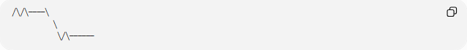
╱╲╱╲────╲
╲
╲╱╲──────
Several different local zigzag patterns occur in one overall path.

Classification Summary
# Source: AI Source: Provided by: [Data Path: Persons Table -> ID Column: 1, Name_En Column: Motasem Essam] -> From: [ChatGPT] on [7/25/2026]
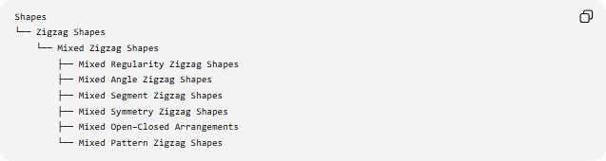
Shapes
└── Zigzag Shapes
└── Mixed Zigzag Shapes
├── Mixed Regularity Zigzag Shapes
├── Mixed Angle Zigzag Shapes
├── Mixed Segment Zigzag Shapes
├── Mixed Symmetry Zigzag Shapes
├── Mixed Open–Closed Arrangements
└── Mixed Pattern Zigzag Shapes
A more general classification is:
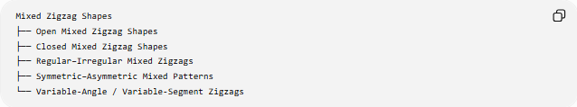
Mixed Zigzag Shapes
├── Open Mixed Zigzag Shapes
├── Closed Mixed Zigzag Shapes
├── Regular–Irregular Mixed Zigzags
├── Symmetric–Asymmetric Mixed Patterns
└── Variable-Angle / Variable-Segment Zigzags
These categories can overlap.

Key Points
# Source: AI Source: Provided by: [Data Path: Persons Table -> ID Column: 1, Name_En Column: Motasem Essam] -> From: [ChatGPT] on [7/25/2026]
- A Mixed Zigzag Shape combines different geometric characteristics within one overall arrangement.
- It may combine regular and irregular sections.
- Its segment lengths or angles may vary.
- It can be open or closed.
- It may contain symmetric and asymmetric portions.
- A collection containing separate open and closed components should be described as a mixed collection of zigzag components, rather than as one closed polygon.
- “Mixed zigzag” is a descriptive classification, not a strict standard polygon class.
- If a mixed zigzag forms a simple closed polygon, standard polygon formulas can be applied.

Conclusion
# Source: AI Source: Provided by: [Data Path: Persons Table -> ID Column: 1, Name_En Column: Motasem Essam] -> From: [ChatGPT] on [7/25/2026]
A Mixed Zigzag Shape is a zigzag arrangement in which different patterns or geometric properties occur together. Its defining feature is the combination of characteristics, rather than a single uniform rule. This makes mixed zigzags useful for describing complex or highly variable angular forms.

